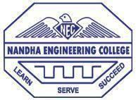 **NANDHA ENGINEERING COLLEGE**

**(AUTONOMOUS)**

**(Approved by AICTE, New Delhi and Affiliated to Anna University, Chennai) Perundurai,Erode-638052,TamilNadu,India.Email:**[**principal@nandhaengg.org**](mailto:principal@nandhaengg.org)

**Website**[**:www.nandhaengg.org**](http://www.nandhaengg.org/) **Phone:04294-225585**

**CRITERION IV**

**INFRASTRUCTURE AND LEARNING RESOURCES**

**4.1 - Physical Facilities**

**4.1.3-Number of classrooms and seminar halls with ICT -enabled facilities.**

**ICT ENABLED CLASSROOMS**

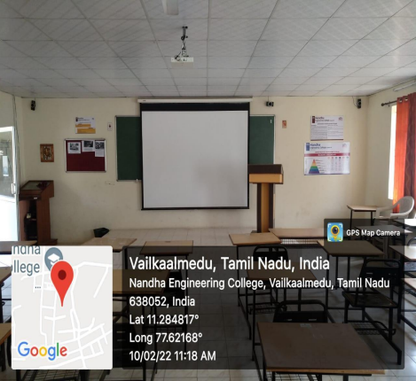

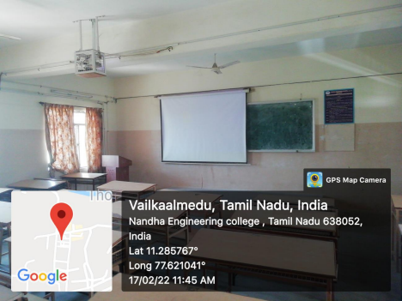

**ICT ENABLED SEMINAR HALLS**

